Table of Contents
Why: Objective 2
How: Communication Strategy 2
Who: Target Audience? 3
Where: Channels 4
Escalation Process 5
Timeline 6
Risks & Dependencies 6
Project Plan 6
Use the RMR Strategy 7
Project Approach 8
Acquire tooling /Servers 8

Why: Objective
- To create awareness about the transformation from SharePoint 2010/2013 to SharePoint Online/2016 among defined group of audience
- To secure the commitment of stakeholders during this transformation
- To enable individuals to understand the impact of change and adapt accordingly
- To encourage participation of Site Information Owners and Site Administrators during the process of migration

How: Communication Strategy

The communication strategy will involve the following steps:
- To define the target audience and segregate them into different groups based on department and companies
- To select appropriate communication channel, as per the communication activity, and the target audience.
- To define the clear and concise message to deliver the objective of communication
- To plan a communication timeline accommodating follow-ups, escalations and schedule slippage
- To implement communication activities, as per defined timelines

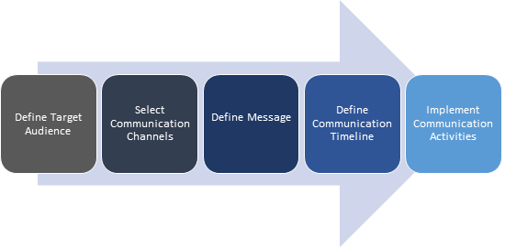
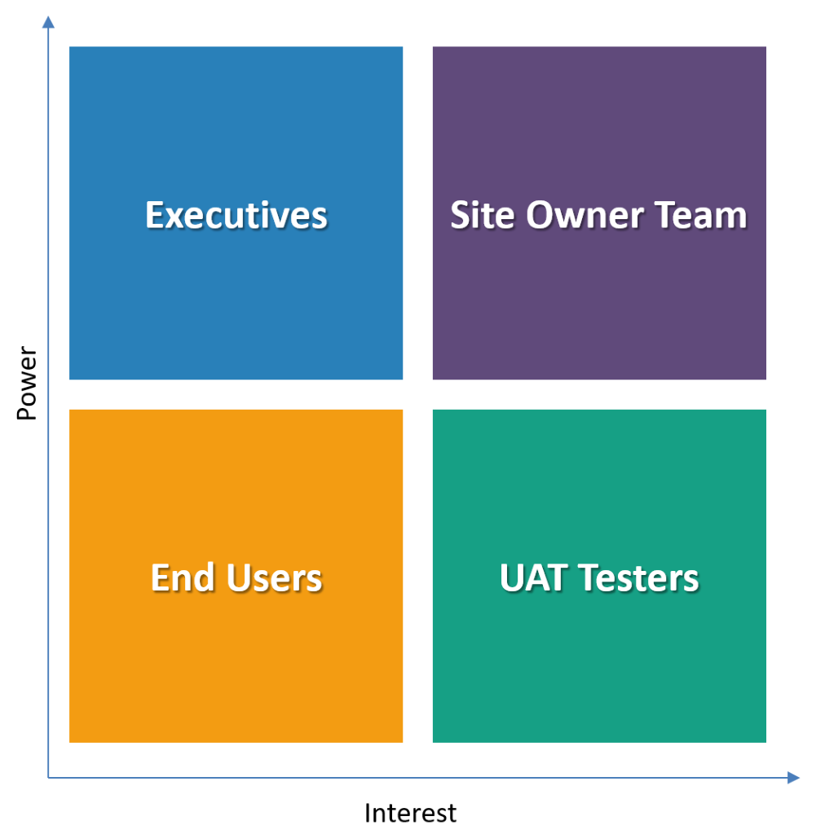

Who: Target Audience?
This section will provide the various target audience to be reached out to, with communications, during the conversion process.
Target audience, based on the influence and the impact they can make on the project are listed as follows:
- Stakeholders/Executives: Executives from all departments can demonstrate support, in the following ways:
- To introduce the project to their teams to bring awareness and participation
- To drive Site Owner team to involve in the project
- Site Owner Team: Identified Site Information Owner and site collection administrators (Primary and Secondary). Site Collection Administrators will be involved in the following activities:
- Trainings, to develop competencies for the new system
- Cleanup of redundant data
- Issue remediation(s)
- Drive UAT testers to test the new system
The Site Owners Team has been further classified by the following ways:
- Migration sprints
- Departments
- Companies
- Locations
- C-level
Detailed Site Owner Analysis document is available here.
- UAT Testers: Identified UAT testers will be involved in the following activities:
- To validate new environment
- To raise concerns/issues
- To participate in defect triage sessions
- To provide UAT Sign-off
- End Users: Beneficiaries from respective departments

The stakeholder matrix displayed below will help us determine the level of participation of target audience required during the process

Where: Channels
This section provides various channels to be utilized for communication during the tenure of project. The choice of channels will depend on the type of message to be delivered and the profile of audience.
Few recommended communication channels are as follows:

- Email: Share project updates to the Site Owner Team, UAT testers and end users.
- Newsletters/Communication Infographic /Yammer Posts: Newsletter/Yammer posts to help everyone understand the purpose and need for change from legacy SharePoint 2010 system to SharePoint Online. Take feedback from the users are see where can it fit into the roadmap.
- Intranet webpages: Insert banners/ messages in intranet to promote awareness.
- Training: A form of interactive communication channel which will help Site Owner Team to explore the capabilities of new system.
- Team Meetings/ One-One meetings/Workshops: To collaborate with Site Owner team during the tenure of project.
- Announcements in legacy systems: Insert prominent announcements and notifications in SharePoint 2010 sites to be migrated.
- Organizational Change Management site: Create OCM site where users can find the following information:
- Dashboard -Site Information /Actions to be performed (Remediation’s)/Site Assessment
- Surveys/Questionnaire
- Training Calendar/Training Materials
- Sprint Timeline
- Successful migrations
- FAQ’s
- Contacts
- Surveys: Post implementation surveys to analyze effectiveness
- Roadshows/Town Hall Presentations/Promotional Newsletters: Post sprint implementation to encourage users to adopt to new system

Escalation Process
This section provides the escalation process to be followed during the tenure of project for speedy response and resolution of issues. This is identified in terms of the key members involved during communication and the next authority in line to address the issues.
The issues which may require attention and escalation are as follows:
- Technical: Technical issues, such as:
- Unable to convert custom solution within the frame
- Non-availability of source code
This section provides the escalation process to be followed during the tenure of project for speedy response and resolution of issues. This is identified in terms of the key members involved during communication and the next authority in line to address the issues.
The issues which may require attention and escalation are as follows:
- Technical: Technical issues, such as:
- Unable to convert custom solution within the frame
- Non-availability of source code
- Customer Response: If a satisfactory response period for an activity for the site owner team has elapsed the SLA, the issue is escalated to the next level for further action. The types of issues are as follows:
- Elapsing response duration for Pre- migration questionnaire
- Elapsing response duration for Site Owner Team Workshop
- Elapsing response duration to perform User Acceptance Testing
- Elapsing response duration to provide Go-Live Date

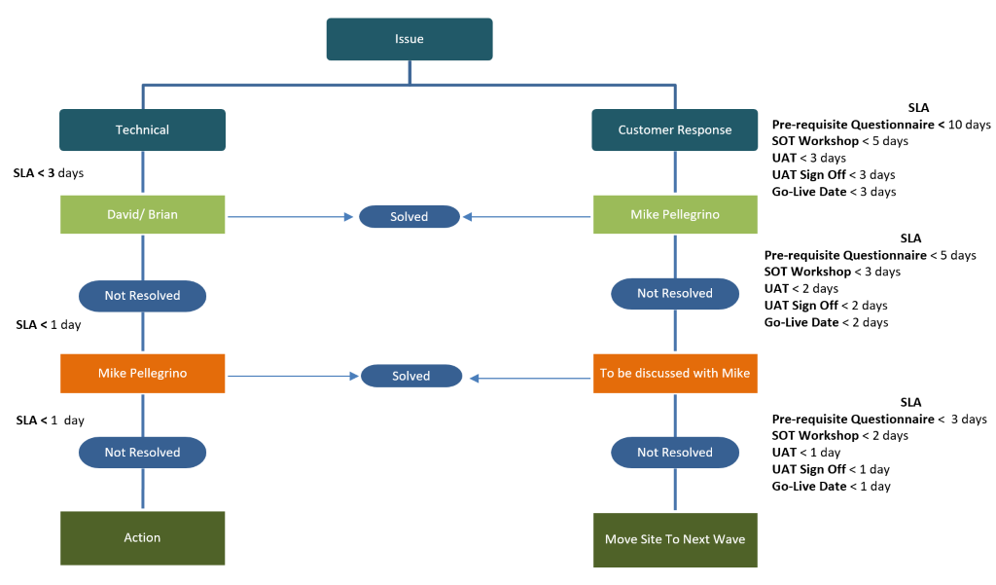

Low | Issues with minimal impact on migration schedule
High | Issues which requires priority response which will impact schedule

Timeline

Risks & Dependencies
- Keeping track of sites being moved for more than 2 sprints.
- Delayed response from site owners, beyond escalation timeline
- Change of ownership (site owners)

Project Plan
Before we create our migration plan, we should know what to expect after the project is over.

SharePoint upgrade vs. migration
Once system requirements are assessed and an organization is ready to make the switch, the first step is understanding the difference between an upgrade and a migration. An upgrade involves a complete transfer of SharePoint databases from one version to the next. Those databases are then upgraded to the new versions schemas.
Migration, on the other hand, involves moving entire SharePoint farms and their data from one database to another, and it typically requires a SharePoint migration tool.

Upgrading to SharePoint 2016
During an upgrade, SharePoint 2016 can be installed directly on top of an existing SharePoint 2013 installation using natively available tools. An upgrade from anything older than SharePoint 2013 is not possible.
This means organizations that have older versions of SharePoint, such as SharePoint 2010, will not be able to perform a leapfrog SharePoint upgrade. In other words, an organization would have to upgrade from SharePoint 2010 to SharePoint 2013, and then from SharePoint 2013 to SharePoint 2016. Note that as you transition from SharePoint 2010 to SharePoint 2013, you will have to upgrade the content database and your site collections before you can migrate to SharePoint 2016.

Migrating to SharePoint 2016
If you are currently using something other than SharePoint, such as Documentum, or are using SharePoint 2010 or older, than a SharePoint 2016 migration might make more sense than an upgrade.
Define on paper the criteria for a successful SharePoint migration. When do you expect the migration to be complete? What content should absolutely be moved? Should it be branded? Etc.

Use the RMR Strategy
Before we can create our roadmap, we need to know what we’re going to migrate.
Remove, Migrate and Rebuild.

Remove
These are the sites you do not plan on moving. Note the word Remove- this means we are explicitly deleting them or leaving them on the old SharePoint, if they are isolated in their own database.
The idea is that these Sites will not be moved to the new SharePoint farm.

Migrate
These are the sites that will be migrated to SharePoint. How? That’s up to you! Choose the type of migration you think is best for you.
Both SharePoint 2013 and 2016 offer deferred Site Collection upgrade, where the Site Collection administrator can upgrade it himself after an upgrade preview.
At a granular level, you could upgrade the Site Collection to 2013 or 2016, then use a combination of export/import to move individual sites. Though this could prove challenging depending on your SharePoint.
Finally, you could use following options to migrate. Again, how you choose to migrate is up to you.
- Metalogix(Now Quest)
- ShareGate
- SharePoint Migration Tool

Rebuild
Another option is to completely rebuild the site in the new version. This usually happens to heavily customized sites in SharePoint 2007 or SharePoint 2010.
With new Web Parts and Apps available in SharePoint, there are probably a few sites that either won’t work or just need to be rebuilt to take advantage of a new architecture and solutions.

Project Approach

Acquire tooling /Servers
Microsoft has a very detailed article which shows every single feature in a complete Edition Comparison Chart of SharePoint 2013, both On-Premises, Online and Office 365.
Migrate from SharePoint to Office 365 or SharePoint Online – Supported Scenarios
After planning your migration and evaluating the available subscription plans, you’ve identified the content you want to move to Office 365. But how do you proceed?
We've identified 5 different ways to upgrade to Office 365 or SharePoint Online.
- Manually copying files
- Using the Office 365 Migration API
- Using custom coded solutions or a third-party tool
- Microsoft FastTrack
- Hybrid
- Manually Copying Files to Office 365
I included this method because I have to, but it's important to note that, in my opinion, it's the least practical way to migrate.
One way this can be accomplished, is by taking the files using the Explorer View in SharePoint, and moving them manually to the destination. However, by doing it this way, you will lose all metadata as well as the "Created by" and the "Created date". They will be replaced by the person responsible for the copying, at the time he is doing it.
This isn't recommended, because you don't want all your documents to suddenly be owned by one person and all modified at the same date and time.

- Using the Office 365 Migration API
The Office 365 Migration API is a newer way to approach a migration that boosts the speed of migration of files by leveraging Azure.
Essentially, you export your content into a migration package that is sent to Azure Storage. When the timer job runs in Azure, they'll take that package and put the content in your Office 365 environment, based on your package settings. If you're looking for a more in-depth, technical explanation, we've written extensively on the subject before.
This is a quick solution developed by Microsoft to make your migration easier; however, it’s fairly complicated to set up, and is only for moving content. You’ll need to prepare the entire environment beforehand for it to receive the migration packages.
Using Custom Solutions or Third-Party Office 365 & SharePoint Online Migration Tools
You could develop your own coded solution to move content over to Office 365, but chances are the time, effort and support that will go into that will be huge when compared to what a third-party tool like Quest, Sharegate, SharePoint Migration Tool can offer.
It could be worth it to look into a tool that can simplify and accelerate your migration process.
- Data Migration with Microsoft FastTrack
For Office 365 customers with 150 seats or more, Microsoft offers a free data migration service that can also help guide administrators with their move, thanks to tools and other documentation. More information and details on the more technical aspects can be found on TechNet and on the FastTrack website.
- Hybrid Upgrade to Office 365
In this scenario, which isn't technically a migration scenario per se, we have both environments running, On-Premises and the cloud. In this Hybrid mode, the environments are linked.
Basically, instead of moving your older content to the Cloud, the idea is to keep running your On-Premises SharePoint and slowly start using Office 365 by creating new Sites there, instead of in the old SharePoint.
After this connection has been made, users will be able to navigate seamlessly between the two, not realizing when they are in one or the other.
This way you can have a more seamless transition as you upgrade or move content to the cloud. Granted it doesn't provide a way to actually move sites from one place to the other, but in some cases, you simply do not need to. Remember the RMR Strategy.
- Migrate to Office 365 on your Own
Migrating to the cloud is a big endeavor and can bring lots of positive changes to the way an organization collaborates. Choosing the right way to get there is probably the most crucial step, so it's important to do extensive research on which method best suits your needs.
The manual migration scenario simply doesn't work for me, as the integrity of the documents isn’t kept. The migration API is a quick and easy way to move your content from a source to a destination, as is the FastTrack method, if you have the right number of seats.
The Hybrid scenario is great and I strongly recommend you use it during your transition, however it provides no real solution to move your content over. Your best bet would definitely be to use a custom solution or a third-party tool that can get everything done with minimal effort.

