The SharePoint landscape has a quite fascinating history. The product currently has at least 5 versions still in active use - SharePoint 2007, 2010, 2013, 2016 and Office 365.
But that’s not all; SharePoint 2019 is soon to join the family). Delve a little deeper and we're sure that SharePoint 2003, and even 2001, are still kicking around somewhere in the darker corners of some companies.
Over the years, and across these versions, we’ve seen quite significant changes in SharePoint. The product has evolved enormously and we wanted to take a look at exactly what’s changed.
This blog post is the first of three posts that's going to look at the key differences between SharePoint versions.
To start, it might help if we build a quick timeline of recent history:
- SharePoint 2007: Released in 2006
- SharePoint 2010: Released in 2010
- Office 365: Released in 2011 (With SharePoint2010 interface)
- SharePoint 2013: Released in 2012
- Office 365 Upgraded: 2013
- SharePoint 2016: Released in 2016
With each release, Microsoft has added new features and rebuilt others. A quick summary of these is as follows:

SharePoint 2007
- Introduction of Excel Services
- Introduction of Content types
- Introduction of SharePoint Designer (Post FrontPage era begins)

SharePoint 2010
- Introduction of the “ribbon”
- Early social networking features
- Overhaul of the Shared Service Providers in favor of Service Applications and the ability to pool them
- Sandboxed solutions and client access to the API
- PowerShell support
- Two-way BCS
- New UI with Fluent Ribbon, using wiki-pages rather than 'web-part pages' and offering multi-browser support.
- New social profiles, and early social networking features
- Central Administration rebuilt.
- Restructure of "Shared Service Providers" - Introduction of "Service Applications" SOA model.
- Sandboxed Solutions and a client-side object-model APIs for JavaScript, Silverlight, and .NET applications
- Business Connectivity Services, Claims-based Authentication, and Windows PowerShell support

SharePoint 2013
- Cross Browser Support
- Drag/drop Uploads
- More social features
- Addition of the audit center
- Re-engineered search facilities
- Cross-browser drag & drop support for file uploads/changes, and Follow/Share buttons
- OneDrive for Business (initially SkyDrive Pro) replaces MySites and Workspaces.
- Updates to social network feature & new task aggregation tool.
- Database caching, called Distributed Cache Service [38]
- Content-aware switching, called Management
- Audit center (service called eDiscovery)
- Rebuilt and improved search capabilities
- Removal of some analytics capabilities
- UI: JSLink, MDS, theme packs. No WYSIWYG in SP Designer.
You may have noticed that we don’t have a section for Office 365 in the summary above. The reason for that is simple; the differences between the Cloud version of SharePoint (known as Office 365 to most) and On Prem SharePoint are vast, which brings the question.

SharePoint 2016
- Mobile Experience
- Personalized Insights
- People-Centric File Storage and Collaboration
- Content Database Size increased from 200 GB to 1TB
- Maximum file storage from 2GB to 10GB
- Non default ports can be used for connection encryption, rather than just using Port 25
- Faster Site Creation
- Project Server integration with SharePoint content databases
- Durable links
- Support for Open Document Format (ODF) Format
- Hybrid Improvements
  - Single Sites View
  - Unified Search
  - Search Sensitive Information in Hybrid Search
  - Unified UI (O365)
- Performance, Scaling & Deployment Improvements
  - Search Scaling Capabilities
  - Site Collection Enhancement
  - Deterministic View Threshold – Removing 5000 Limit
  - Durable Links and Large Files Support
- Deployment Improvements
  - MinRole
  - Zero Downtime Patching

On Prem or the Cloud?
We’ll get to the various feature sets shortly, but first let’s have a look at the differences in hosting and licensing of these two different models.
As with most On Prem vs Cloud discussions, the most significant difference affects local IT resources (inclusive of software, hardware support and skill maintenance of support staff) vs the convenience offered by cloud solutions. Cloud hosted systems almost certainly provide better business continuity procedures than an on-premise solution. Other points to consider are:

On Premise Solution | Cloud Solution
- SP farm hosted locally  - IT team responsible for farm, patching and change control  - On-premise AD is required | - SP farm resides within the Microsoft Data Centre Network  - MS host and patch the environment  - MS SLA commits to 99.9% availability

A special note needs to be given to Office 365 licensing. With an on-premise solution, you’re able to differentiate between standard and enterprise licenses. With Office 365, this licensing isn’t so clear cut.
Microsoft has come up with a number of plans that are intended to cater for firms of different sizes. These not only have different features rolled into them but have a different price point per user per month. In summary, these are:
- Office 365 Business Essentials ($5 per user per month)
- Office 365 Business ($8.25 per user per month)
- Office 365 Business Premium ($12.50 per user per month)
More information is available here, though obviously pricing will vary by country and region.

Different features set
On Prem and Cloud SharePoint, or rather Office 365, also differ by feature set. Back in the early days of Office 365 these differences were quite pronounced. Office 365, or its even earlier incarnation BPOS (remember that one!), was quite a way behind SharePoint 2010 and 2013.
Then Microsoft really started to focus on the Cloud and Office 365 started pulling ahead in terms of what it offered end users. Microsoft is now looking at bringing some of the more advanced Cloud features of Office 365, like Delve, to those still operating On Prem SharePoint - the release of SharePoint 2016 will start to address this.
Office 365 does currently have a number of ‘exclusive’ features. These features include:
- NextGen Portals: Out of the box “ready to go” portals
- Delve: A technology based on Office Graph that presents “relevant information” to you based on your actions and interactions with colleague, files and so on.
- Sway: A presentation web par that allows users to combine text, images and videos locally and from the wider internet to create a usable website.
- Yammer Integration: Yammer is the enterprise social network that's being gradually rolled into all Office 365 features. Single sign-on was achieved recently and soon comments and conversations will be possible in Yammer groups
- Office 365 Groups: This is a way of using different Office 365 applications together. For instance, syncing lists between applications
- Regular updates: Over the last 12 months over 450 updates have been rolled out with more coming all the time.

A changing picture
What we hope we’ve shown you with this initial post is some of the growing differences between SharePoint versions and Office 365. As we said, this picture is changing. Microsoft are addressing some key concerns from users in regards to the product and rolling these out across Office 365.
SharePoint 2016, as well as its cloud version on Office 365, looks like it’ll be blurring the line between the two solution types even further as it’ll look to bring some of the current cloud based solutions back down to the ground.

SharePoint 2019
- New UX features
- Team site updates
- Communication site improvements
- Hybrid OneDrive environments
- IT administration & infrastructure updates
- Integration with hybrid environments
- SharePoint training courses
- Sync files with OneDrive sync client (NGSC)
- Use of # and % characters in file and folder names

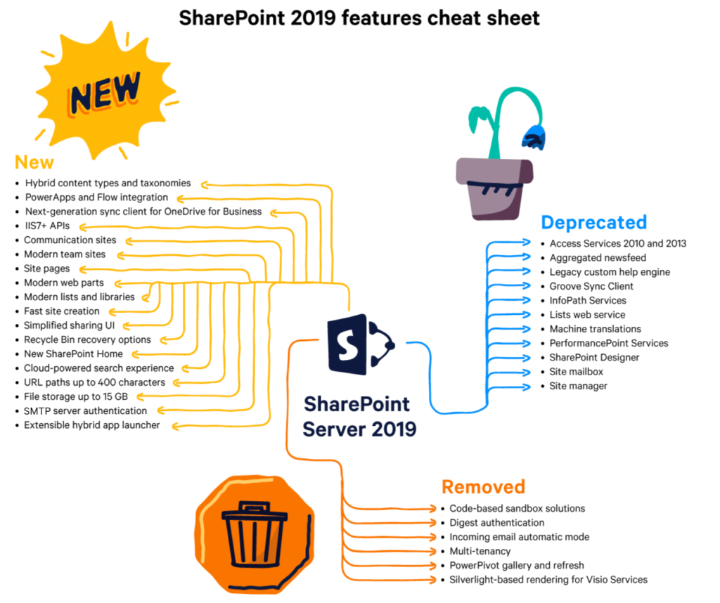
References:
- https://docs.microsoft.com/en-us/sharepoint/what-s-new/new-and-improved-features-in-sharepoint-server-2016
- https://docs.microsoft.com/en-us/sharepoint/what-s-new/new-and-improved-features-in-sharepoint-server-2019
- https://www.newhorizons.com/article/14-new-sharepoint-2019-features-that-make-the-move-worthwhile
- https://sharegate.com/blog/whats-new-in-sharepoint-2019-features-overview-cheatsheet

